**aSTAR Activity - Employment Communications (Ch.16)**

Objective: This worksheet guides you through exercises to ensure your résumé shows your most marketable skills and to prepare you to respond to common interview questions. The STAR approachhelps us by encouraging us to identify and talk about those personal attributes and professional abilities that make us unique and effective during the employment process.

**Part 1: Identifying your key selling points**

Your key selling points, or what makes you a competitive candidate for the job search process, are your unique *attributes* and *abilities*. Attributes are personal characteristics that make you who you are, while abilities are job-related knowledge and skills. Both attributes and abilities come from our experiences. List below a few attributes and abilities that describe you the best (refer to the Chapter 16 PP for ideas):

|  |  |
| --- | --- |
| Attributes:   * Self-Motivated * Loyal | Abilities:   * Fluency in Foreign Languages * Experience with relevant technologies |

One common question you may be asked during a networking or interviewing situation is “Tell me about yourself.” Even though this question should be easy for us to answer (because it’s about us!), it often causes stress for professionals. Analyze these sample responses below:

|  |  |
| --- | --- |
| *Less effective* | *More effective* |
| “Well, I’m a recent graduate with a degree in Finance. I also minored in Event Management. I have worked for a credit union for the past five years. I started out as a teller and moved up from there. Prior to working at the credit union, I worked at a medical supply company and a tanning salon. Outside of that, I’ve been heavily involved in sports my whole life. And that brings me right up until now, ready to move into a new position.” | “About five years ago, I took a position as a teller at a credit union. I found that I really loved the credit union approach to providing financial services. Within months, I realized that this was a career direction for me. I was fairly quickly promoted into other positions—first as a teller supervisor and then as a loan officer and marketing specialist. While working at the credit union, I also went to Florida State University, where I majored in Finance and minored in Event Management. I focused all of my studies on my deep interest in marketing financial services for credit unions. One reason I’m so intrigued by the position is that it combines several of my key interests.” |

Why do you think the *More effective* answer would be a better response to the question? Which attributes and abilities can you *see* demonstrated by the response on the right?

It’s a better response because shows his confidence, he went straight to the point in telling his experience and showing interest in what he is doing and knows what he is doing. With that, he also shows growth in his job from going from teller to a loan officer to marketing specialist.

**Part 2: Integrating your key selling points**

Ideally, your response to the question “Tell me about yourself” should make a strong impression to a potential employer by demonstrating why you would be an effective professional.

Brainstorm: What would I say about myself?

I have knowledge in, SAP, Microsoft, Excel, Access and fast typing skills. My strength is that I’m an enthusiastic and dedicated person. What I’m looking for is a company I could have to produce a positive return on investment and where I could join a strong team.

Résumé check: Are my key marketable skills shown in my résumé? Yes  No

**Part 3: Outlining your success stories using the STAR approach**

The STAR approach is a useful tool for crafting and telling stories about your experiences in a concise and detailed way. The acronym STAR refers to the main pieces of an effective story: Situation (what was happening), Tasks­ (what you needed to do/the problem that needed solving), Actions (what you did), and Results (how it went/what happened). Stories are important for network situations and interviews because they provide the details and examples that SHOW your abilities and attributes (rather than just telling someone you can do something without evidence). Some common interview questions include the following:

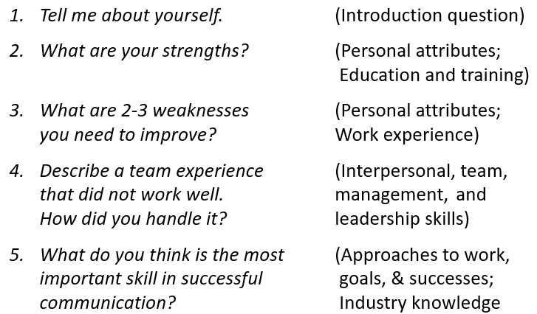

Once you have a few STAR stories ready, you will find that you can use them to answer a variety of questions about your background and experiences. For example, a story about when I was the leader of a team project could SHOW my leadership, communication, management, and technology skills. Outline one story below:

Tell me about a time you were a successful problem-solver.")

**S**ituation: As telemarketing seller you get to deal with clients with many complains. A customer called upset because he was struggling to get electricity and water services to his property.

**T**asks: My duty was to help solve his problem. And the first thing I did was calm him down and offer him my help.

**A**ctions: After the client is calm, I explained what he had to do and provided him with the necessary information to obtain his utilities, which was a list of phone numbers that he can call depending on the county where he lives.

**R**esults: The client was able to communicate with the indicated personnel and obtained his utilities on his property and was satisfied with the service

*Practice yourself saying aloud your STAR story details. Time your story (aim for 30 seconds to 2 minutes).*